Three group, Heterogeneous Transport Equation Solver

18 April 2022

Zach Condon

and

Sunday Agbo

**Table of Contents**

**Introduction**  3

**Mathematics** 4

SN Method 4

Angular Discretization 4

Spatial Discretization 5

Multiple Groups 5

Diamond Difference 6

Transport Sweep 6

Source Iteration 7

**Algorithms 7**

**Results and Discussion** 9

**Conclusions** 22

**Introduction**

The determination of the neutron flux is a core objective of computational nuclear reactor analysis. The spatial and energy distribution of neutrons within a reactor directly determines key reactor safety and operational parameters such as criticality, local peaking, fuel burnup, and vessel fluence. To design a reactor and verify safety, it is necessary to calculate the neutron flux under a variety of operating conditions and potential accident scenarios.

The neutron transport equation describes the neutron population in a reactor (Stamm’ler and Abbate, 1983). The prediction of a correct neutron population is very important to have a safer and more economical reactor design. For purposes of steady state reactor core design, the solution for the one speed time-independent linear neutron transport equation is very paramount. As such, a code that solves a three-group neutron transport problem using the discrete ordinates approach was developed in this project. The equation is essentially a statement of neutron balance with the angular neutron flux as the unknown principle, i.e.

|  |  |  |
| --- | --- | --- |
|  |  | 1 |

where is the macroscopic total cross section and Q is the particle source distribution which includes the scattering term and source term. The angular flux is defined as a product of the neutron speed v and the neutron angular density (Class Notes).

The transport equation is very difficult to solve analytically, but discretization methods can be used to solve it numerically. This discrete-ordinates approach is used to approximate the angular flux at a set of spatial mesh points and in a discrete number of fixed directions. The unique directions are dependent on the discretization scheme. For our project, after selecting a number, *N*, of discrete angles of Gauss-Legendre quadrature points, we performed a discretization for the x spatial variable. The technique we employed consisted of replacing the differential terms in Eq. (2), with finite difference relations and the angular flux in the collision terms by the diamond difference (DD) relations; then the source term including the scattering source was expressed in the Legendre polynomial base. A detailed description of the discrete ordinates approach, the source iteration method employed, the results obtained, and the discussion of the results are presented in this report.

The second part of this project is concerned with developing a code that solves (calculates the scalar flux) a monoenergetic, steady-state transport equation for a homogenous finite medium with no fission, vacuum boundary conditions on both sides, isotropic scattering, and homogeneous isotropic interior source.  The results obtained are compared with the corresponding diffusion equation with the same characteristics and are discussed.

**Mathematics**

**The SN method**

Discrete ordinates method was first introduced by Carlson in 1955 (Carlson, 1955) in the context of reactor physics for the computation of particle transport. Chandrasekhar applied this method in the field of astrophysics (Chandrasekhar, 1960), it further finds application in the radiative transfer studies by Lathrop in 1966 (Lathrop in 1966). The S**N** method is a special case of the discrete ordinates method. The S**N** method or discrete ordinates is a collocative method. It uses the integro-differential form of the transport equation and involves a special treatment of the angular variable. The treatment of spatial variables is often based on a finite difference scheme called a diamond scheme. For this project, we started with the steady-state transport equation for monoenergetic neutrons in a slab geometry (Lahdour et al., 2019) for which the transport equation is therefore given by Eq. 2.

|  |  |  |
| --- | --- | --- |
|  |  | 2 |

where:

is the angular flux of neutron at position x traveling in direction .

is the cosine of the angle between the neutron velocity vector and the positive x-axis.

(x) is the total macroscopic cross-section.

Q is the source.

(x) is the scattering cross section

**Angular Discretization**

To solve Eq. 2, we defined N discrete direction (, , ……. ) and corresponding weight coefficients (, , ……. ). The weights are chosen to approximate the integral of any function f( by weighted sum:

|  |  |  |
| --- | --- | --- |
|  |  | 3 |
|  |  | 4 |

As such, Eq. 2 can be re-written as

|  |  |  |
| --- | --- | --- |
|  |  | 5 |

**Spatial Discretization**

To discretize the spatial variable, let’s define the spatial grid with *I* mesh points as shown in Fig.1 and noting that the cross sections are piecewise constant and may change values only at half – integer mesh point x + . The cell-centered points are defined by

*6*

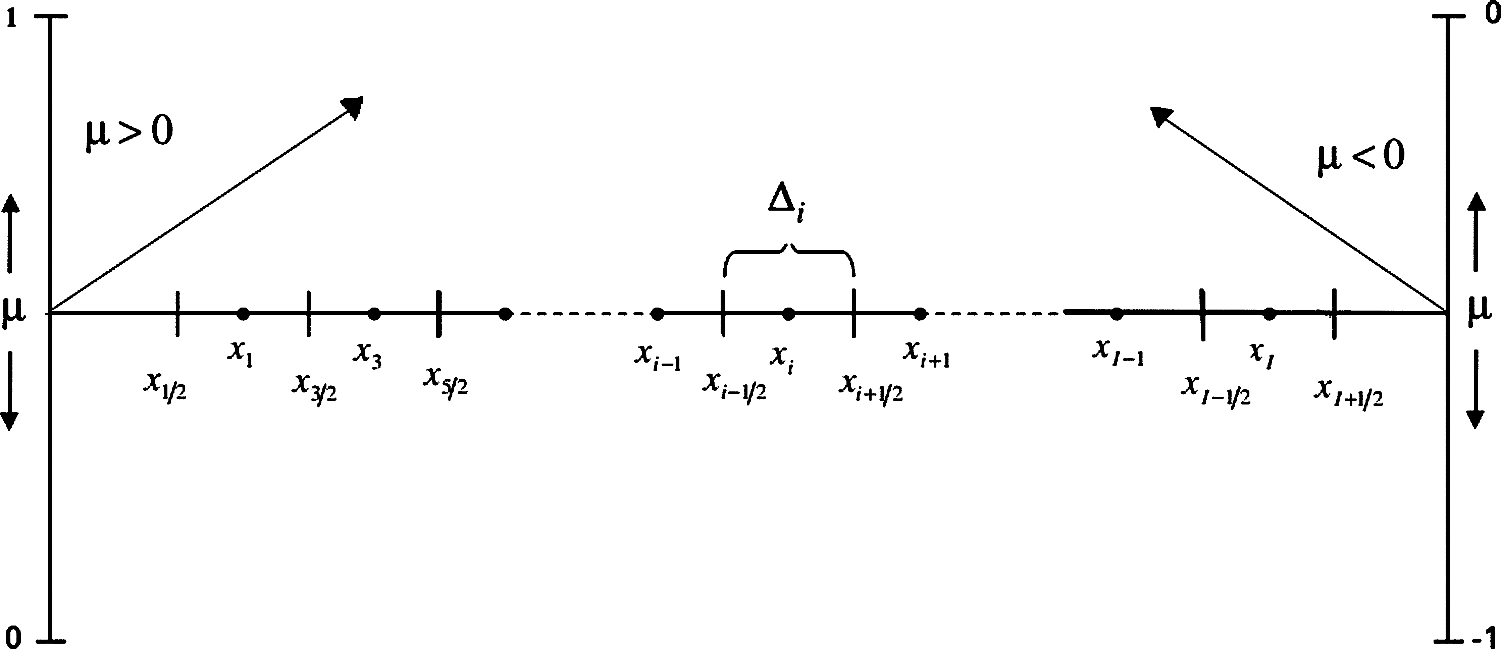

Fig. 1. Spatial discretization in discrete ordinates method.

Equation 5 can be written using the above spatial discretization scheme as:

|  |  |
| --- | --- |
|  | 7 |

in which the lower case *i* subscript denotes each respective value at position *i.*

**Multiple Groups**

For our project, we included three neutron energy groups in which neutrons are able to scatter within their own group or down to lower energy groups. Equation 7 can be rewritten as:

|  |  |
| --- | --- |
|  | 8 |

Similarly, the subscript *g* denotes the group for each respective variable. The partial scattering cross-section, , is the cross-section for a neutron in group *g’* to scatter into group *g*.

**Diamond Difference**

To solve the neutron transport equation described in Equation 8, two approximations will need to be made. First, the spatial derivative will be approximated as:

|  |  |
| --- | --- |
|  | 9 |

where h is the distance between point and . Next, the diamond difference method is then used so that the transport equation only relies on and . This method is defined as:

|  |  |
| --- | --- |
|  | 10 |

and equation 8 may be rewritten as:

|  |  |
| --- | --- |
|  | 11 |

where , the scalar flux, is the sum of all the angular flux values at a particular point, *i*.

**Transport Sweep**

Knowing boundary conditions, equation 11 can now be solved using a method known as a transport sweep. For example, is both boundaries are vacuums, the incoming flux from each side will be zero. This means, for , and if the scalar flux is known, Equation 11 has only one unknown, , and can be solved. Once is calculated, the next positional angular flux can be calculated, followed by the next, etc. The same method can be used going from right to left.

To handle a reflective boundary on the right-hand side, a transport sweep from left to right can be performed. Once the last value has been found, the reflective boundary condition requires that the first angular flux value pointing to the left is equal to the last angular flux value pointing to the right. The sweep can then occur using the defined reflective condition as the initial value.

**Source Iteration**

In the transport sweep described above, the assumption was made that the scalar flux was known. This normally would not be the case, but with numerical iterations, it can be determined. Using *m* to denote the number of iterations, equation 11 can be written as:

|  |  |
| --- | --- |
|  | 12 |

The right-hand side of the equation now lags behind the left-hand side, but this can be used to converge to a correct solution for the scalar flux. By guessing an initial value of scalar flux, the angular flux can be determined using the transport sweep defined above. The calculated value for the angular flux can then be used to determine a new value for the scalar flux. The above process can be repeated until a certain criterion for convergence is met.

For our project, the criterion for convergence was such that if the Euclidean difference between and was more than , the source iteration/transport sweep algorithm would run again.

**Algorithm Overview**

The code developed for solving the transport problem in this project followed an algorithm developed using the methods described in the mathematics section above. Ideally, a code like this will not allow for inputs that are not reasonable to a real-world scenario. We have tried to ensure the code will correctly handle an input vacuum material (ie. if ) or if the total scattering cross section is greater than the total cross-section.

The algorithm is as follows:

1. Initialize parameters of the problem (using the functions *initialize_problem_values, define_cross_sections, define_source, and define_material*). The variables that are set in these four functions are:
   1. Initialize_problem_values
      1. M – the number of materials
      2. G – the number of neutron energy groups
      3. N – the number of angles in the quadrature
      4. Reflective – if the right side boundary is reflective or not
   2. Define_cross_sections
      1. Sigma_t – the total cross-section
      2. Sigma_s – the scatter cross-section
   3. Define_source
      1. Q – the source term
   4. Define_material
      1. Width – the width of each material
      2. I – the number of spatial discretizations
      3. h – the size of the mesh
2. Initialize a guess for scalar flux in the material.
3. Calculate the angular flux using the guessed scalar flux.
   1. Use a left-to-right transport sweep to determine the positive (moving to the right) angular flux in the materials
   2. Determine the far-right angular flux value depending on the boundary condition
   3. Use a right-to-left transport sweep to determine the negative (moving to the left) angular flux in the materials
4. Calculate a new guess for the scalar flux using the angular flux.
5. Compare the new scalar flux to the guess scalar flux using the Euclidean difference.
6. If the difference is less than , the code is finished and the scalar flux has been calculated, but if the difference is greater than , repeat steps 2-5 using the new scalar flux as an updated guess flux.

**Results and Discussion**

**Part 1 - Example solutions:**

Example 1 – All Q values are the same for the groups in both materials. The only difference is the down-scattering cross-section. The fast energy group has the lowest flux values, since its down-scatter cross-section is higher than any of the other groups’ cross-sections. In material two (the right side), the in-scatter cross-section for group 3 is the highest and it is reflected in the graph in Figure 2. The flux for group 3 in material 2 has the highest value of all three groups.

|  |  |
| --- | --- |
| Graphical user interface, application  Description automatically generated  Figure - Material properties for example 1 | Chart  Description automatically generated  Figure - Scalar flux for example 1 |

Example 2 – The values chosen for this example were to see the effects of a large change in source from one material to another. The scatter cross-sections were left the same, meaning we should again expect group 3 flux to be the highest within material 2.

|  |  |
| --- | --- |
| Figure - Material properties for example 2 | Figure - Scalar flux for example 2 |

Example 3 – In this example, the only values that change in the below 8 figures are the number of angles used in the quadrature. As N increases, the flux changes more sharply due to a more exact solution being calculated.

|  |  |
| --- | --- |
| Figure - Material properties for example 3, S2 | Figure - Scalar flux for example 3, S2 |
| Figure - Material properties for example 3, S4 | Figure - Scalar flux for example 3, S4 |
| Figure - Material properties for example 3, S8 | Figure - Scalar flux for example 3, S8 |
| Figure - Material properties for example 3, S16 | Figure - Scalar flux for example 3, S16 |

**Part 2**

The scalar flux obtained from transport equation and diffusion equations for values of M ranging from 5 to 50 in an increment of 5 are plotted and shown in Fig. 13 to Fig. 22 and the plot of Euclidean distance between the transport flux and diffusion flux is shown in Fig. 23.

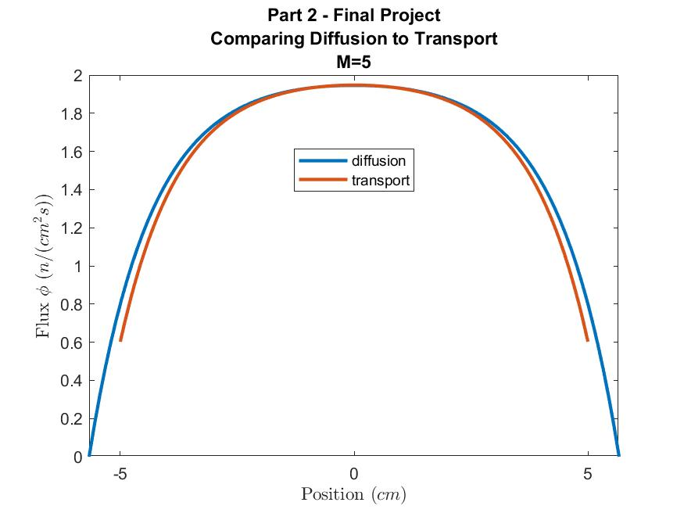

Fig. 13. Comparison between the scalar flux obtained from diffusion and transport Equations for M = 5.

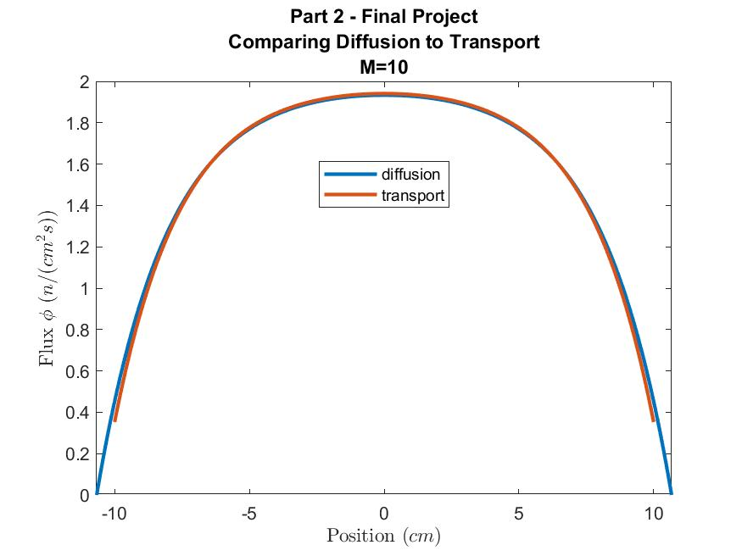

Fig. 14. Comparison between the scalar flux obtained from diffusion and transport Equations for M = 10.

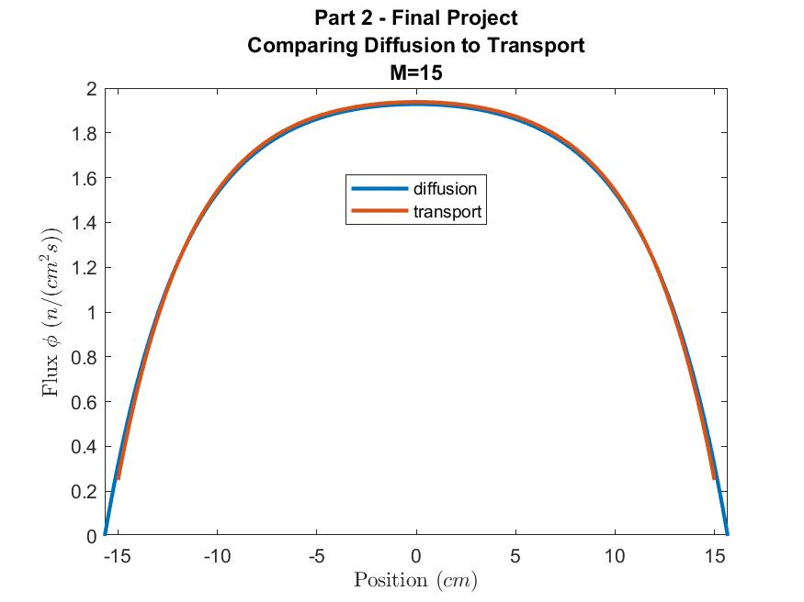

Fig. 15. Comparison between the scalar flux obtained from diffusion and transport Equations for M = 15.

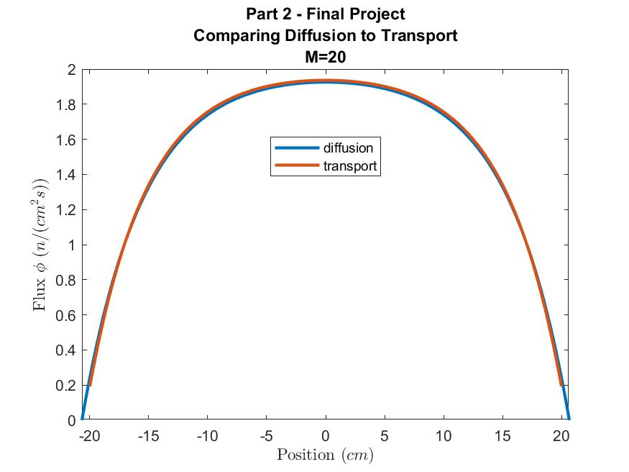

Fig. 16. Comparison between the scalar flux obtained from diffusion and transport Equations for M = 20.

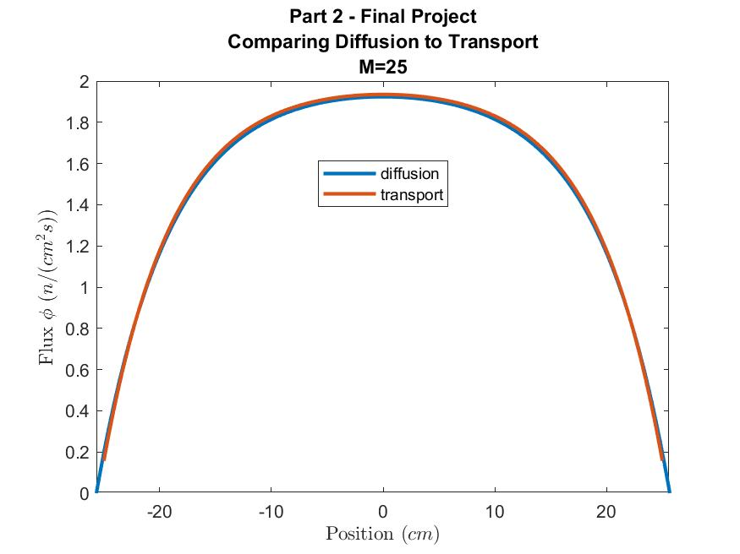

Fig. 17. Comparison between the scalar flux obtained from diffusion and transport Equations for M = 25.

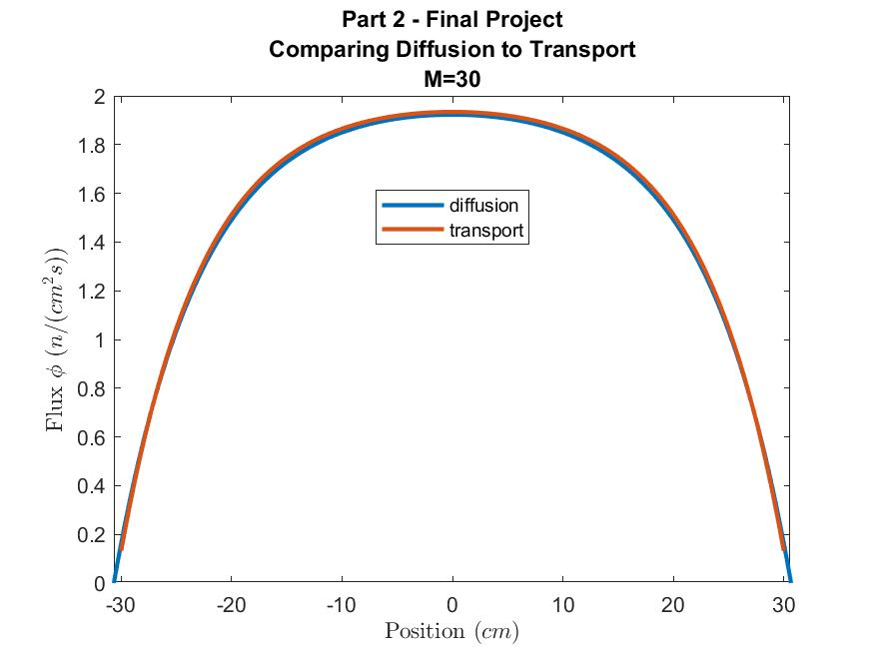

Fig. 18. Comparison between the scalar flux obtained from diffusion and transport Equations for M = 30.

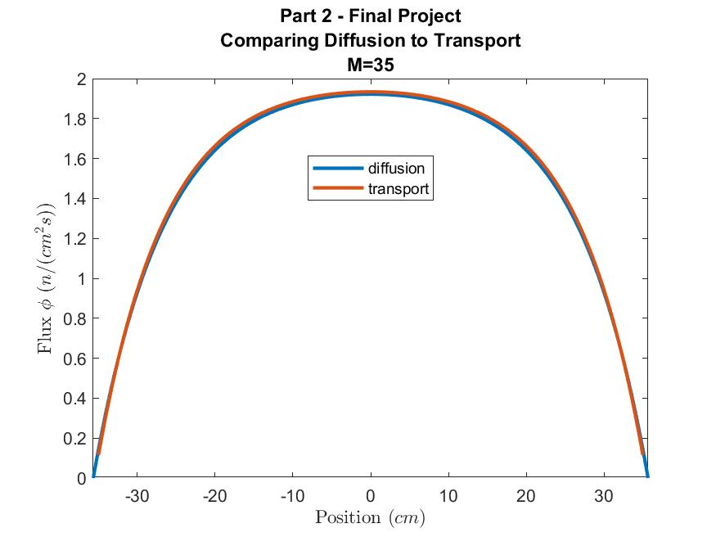

Fig. 19. Comparison between the scalar flux obtained from diffusion and transport Equations for M = 35.

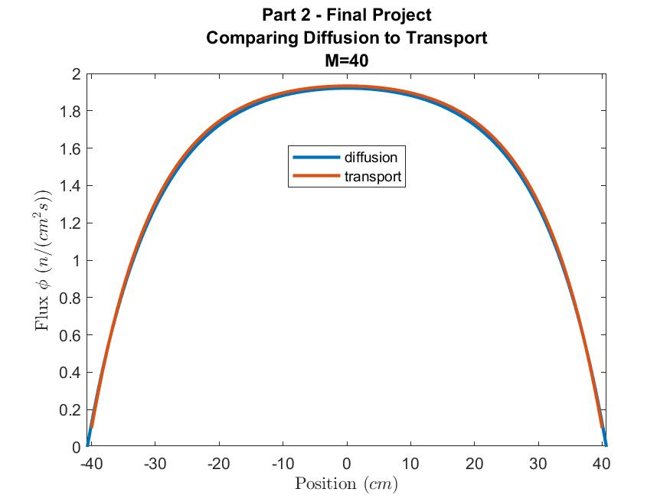

Fig. 20. Comparison between the scalar flux obtained from diffusion and transport Equations for M = 40.

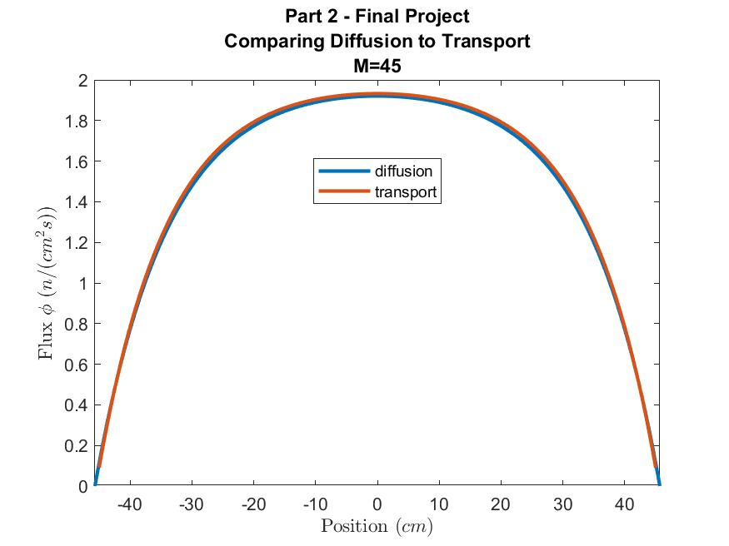

Fig. 21. Comparison between the scalar flux obtained from diffusion and transport Equations for M = 45.

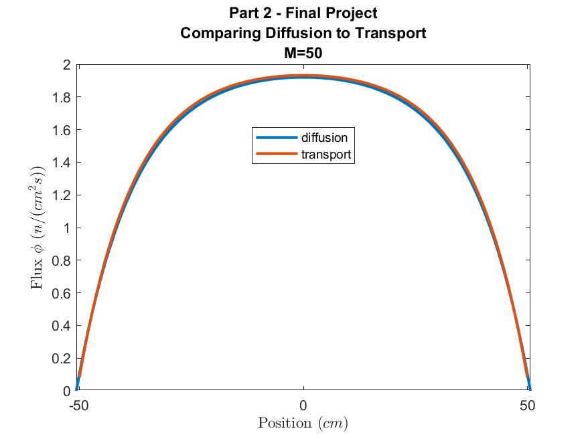

Fig. 22. Comparison between the scalar flux obtained from diffusion and transport Equations for M = 50.

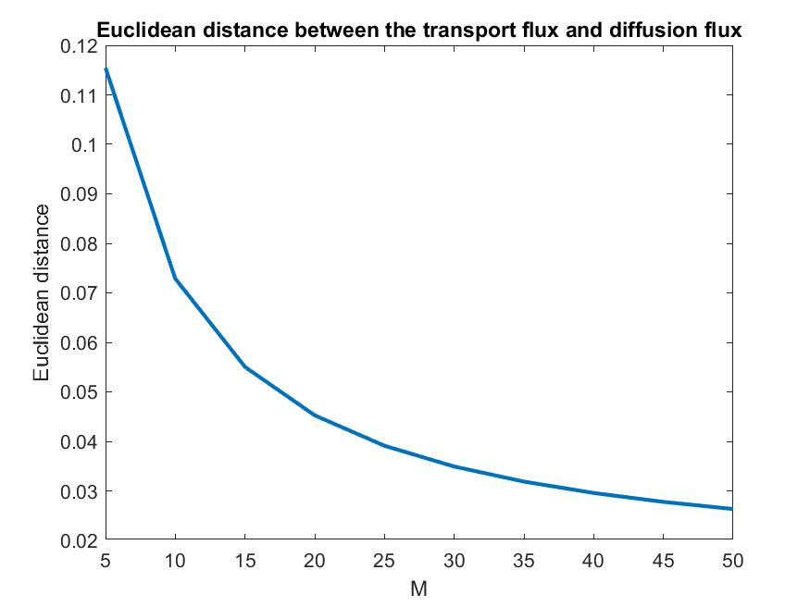

Fig. 23. Euclidean distance between the transport flux and diffusion flux.

As can be seen from the Figures (Fig.13 to Fig. 22), the scalar flux obtained by solving the diffusion equation and that obtained by solving transport equation are converging to each other as M increases. It can be noticed that for M = 50 (Fig. 22), both scalar fluxes are close to converging. The trend observed in the behavior of the scalar flux obtained from both equations (diffusion and transport) is hereby discussed by in three parts; WHY the trend decreases (behavior of the scalar flux as M increases), THE PHYSICAL INTERPRETATION of the behavior and THE MATHEMATICAL INTERPRETATION of the behavior.

WHY

For a system to be diffusive it needs to be large enough so that particles will have enough space and time to bounce several times thereby diffusing through the system. It can be observed that based on the statement of the question, M (the length of the slab) increases from 5, 10……50. So, since M is the length of the slab, it therefore means increasing M implies making the slab/ the system larger. Moreso, based on the given data in the statement of the question, the total cross section ( is 1.0 cm2, meaning the mean free path (the inverse of ) is 1 (not changing). So, by increasing the size of the slab (M), we are increasing the number of mean free path in the system. So, for a diffusive system, we need a large enough system with many free paths.

Secondly, for a system to be diffusive, the absorption needs to be small so that the particles in the system can scatter several times thereby diffusing through the system before they eventually die. As we can see from the statement of the question, the absorption cross section is given by = which means as M increases, decreases (becomes smaller).

Thirdly, for a system to be diffusive, the internal source needs not to be too large so as not to dominate the flux. As such, by making the source small (Q= ), which is the case as M increases, the behavior of the flux is then driven by scattering instead of the internal source.

THE PHYSICAL INTERPRETATION

As M increases, we are approaching the diffusive limit, meaning the system becomes more and more diffusive. This is consistent with the trend as presented in the plots (Fig. 13 to Fig. 22) as it is observed that as M increases, flux from transport equation and diffusion equation converge to each other. The flux from both equations was observed to fully converged at M = 50.

MATHEMATICAL INTERPRETATION

Mathematically, what is happening is that we are approaching the asymptotic limit which we derived in the reactor theory class/notes for the diffusion equation. The derivation as shown in the reactor theory class/note is presented below. It starts with the transport equation given as,

. + = + *13*

then scaling the above equation by a small, positive, dimensionless parameter , such that

(total cross section is large)

(same order as total cross section)

(absorption cross section is small, O ())

(source is small)

Now, rewriting the transport equation based on the above assumptions, we have

= + *14*

Inverting the operator on the left of the Eq. 13, we have

= *15*

Expanding the inverse operator in power series, we have

= *16*

Integrating over the unit sphere and dividing by

= *17*

We get

= *18*

This gives

+ = *19*

Expanding the right-hand side as power series, we have

+ = = + *20*

Taking terms up to O() in the results above and with algebraic manipulation, we have

- = S *21*

The equation above is a diffusion equation. A diffusion equation was derived from the transport equation by scaling the transport equation by a small, positive, dimensionless parameter . So, it has been shown that making the assumptions that absorption is small of the order and source is small of the order , the transportation equation becomes the diffusion equation to leading order with an error of O(). So, in this project, a code that solved the diffusion equation and obtained the scalar flux was developed and the corresponding code for transport equation was also developed. The scalar flux obtained from the diffusion equation has been shown to be at most O() away from the scalar flux obtained from transport equation, which is the asymptotic limit. It should be noted that as presented in the report, is , where M is the length of our slab. So, as M increases, decreases. Meaning as we are increasing M, we are decreasing the error of the asymptotic approximation. As seen from the figures (Fig. 13 to 22), we started with the diffusion equation which is not a good approximation for the transport equation since the in this case is not small ( = , M = 5, = 0.2), as can be seen in Fig.13, the flux from diffusion differs from that of transport. But as M increases (10. 20…..50), the error () becomes smaller and the diffusion flux and transport flux started converging to each other. The diffusion flux and transport flux were seen to fully converge for M = 50 ( = 0.02). This trend was also confirmed in the Euclidean distance between the transport flux and diffusion flux shown in Fig. 23.

Conclusions

This project was in two parts. In the first part of the project, a code was developed to solve a three group, heterogeneous neutron transport equation using the discrete ordinates approach. In the second part of the project, a code that solves (calculates the scalar flux) a diffusion equation for a homogenous finite medium with no fission, vacuum boundary conditions on both sides, isotropic scattering, and homogeneous isotropic interior source were developed. The scalar flux we obtained for various values of M showed that the flux is at the order of epsilon square away from the transport equation. Where epsilon is 1/M. It was observed that as M increases, epsilon decreases, implying that we are decreasing the error of the asymptotic approximation. At M = 50, the error (epsilon) becomes small (0.02) and the flux from the diffusion equation and that from the transport equation converge.

**References**

Class Notes

Carlson, B.G., 1955. Solution of the Transport Equation by SN Approximations. LA (Series) (Los Alamos, NM), vol.1891. Los Alamos Scientific Laboratory of the University of California.

Chandrasekhar, S., 1960. Radiative Heat Transfer, vol. 11. Dover Publications, New York, USA, pp.11–12.

Lahdour, M., Bardouni, T.E., Chakir, E., Benaalilou, K., Mohammed, M., Bougueniz, H., Yaakoubi, H.E., 2019. NTP-ERSN: a new package for solving the multigroup neutron transport equation in a slab geometry. Appl. Radiat. Isot.145, 73–84.

Lathrop, K., 1966. Use of discrete-ordinates methods for solution of photon transport problems. Nucl. Sci. Eng.24 (4), 381–388.

Stamm’ler, R.J., Abbate, M.J., 1983. Methods of Steady-State Reactor Physics in Nuclear Design, vol. 111. Academic Press, London.